INDEX
1.Objective
2. Data Description
3.Tools and Technologies
4. Feature Augmentation
5. Logging and Error Handling
6. Exploratory Data Analysis (EDA) Using Matplotlib
6.1. Visualization Module
6.1.1. Churn Distribution
6.1.2. Telecom Partner vs Gender
6.1.3. senior citizen in telecom partner
6.1.4. Gender Distribution
6.1.5. Gender vs Churn
6.1.6. Gender Breakdown (No Internet Service)
6.1.7. Tenure vs Churn
6.1.8. Contract Type Churn
6.1.9. Internet Service Churn
6.1.10. Payment Method Churn
6.1.11. Senior Citizen vs Churn
6.2. EDA Insights & Implementation
6.3. Conclusion
7. Train- Test Split
8. Feature Selection & Feature Engineering
8.1 Missing Value
8.1.1. Why Missing Values Must Be Handled
8.1.2. Technique selected
8.1.3. Why other techniques are rejected
8.2 Outlier Handling
8.2.1. Why Outlier Handling Is Required
8.2.2. Technique selected
8.2.3. Why other techniques are rejected
8.3 Variable Transformation
8.3.1. Why Variable Transformation Is Required
8.3.2. Technique selected
8.3.3. Why other techniques are rejected
8.4 Categorical to Numerical
8.4.1 Why Feature Encoding Is Required
8.4.2. Technique selected
8.4.3. Why other techniques are rejected
8.5 Feature selection
8.5.1 Why Feature Selection Is Required
8.5.2. Technique selected
8.5.3 Why other techniques are rejected
8.6 Data Balancing
8.6.1 Technique selected
8.6.2. Why other techniques are rejected
8.7 Feature Scaling
8.7.1 Technique selected
8.7.2. Why other techniques are rejected
9. Model Selection
9.1. Data Preparation Before Training
9.2 Model Selected
9.3 Why other Model are rejected
9.4 Optimization via Grid Search
9.5 Visualizing Success (ROC Curve)
9.6 Model Performance Leaderboard
10. Pickling
11. Frontend
11.1. The User Interface (index.html)
11.2. The Prediction Engine (app.py)
11.3. Probability and Decision Threshold
12. Deployment Configuration
12.1. The Core Infrastructure
12.2. Why This Setup Is Industry-Standard
12.3. The Live Inference Workflow

13. Final Project Verdict
14. Conclusion

Churn Prediction Project Documentation
Project: AI-Powered Customer Retention Prediction System
Dataset:https://www.kaggle.com/datasets/blastchar/telco-customer-churn

1.Objective
The Customer Retention Prediction System is a machine learning solution designed to predict customer churn for major telecom partners, including Jio, Airtel, BSNL, and Vodafone. The project transitions from raw data analysis to a functional web-based tool to help businesses proactively address customer turnover.

2. Data Description
The dataset consists of 7,043 rows and 21 columns, representing individual customer records. Below is a breakdown of the key features:
- Customer Demographics – gender, Senior Citizen, Partner, Dependents
- Service Information – tenure, Phone Service, Multiple Lines, Internet Service, Online Security, Online Backup, Device Protection, Tech Support, Streaming TV, Streaming Movies
- Account & Billing Information – Contract, Paperless Billing, Payment Method, Monthly Charges, Total Charges
- Target Variable – Churn

3.Tools and Technologies
- Python: The main language used to write the code.
- Pandas: Used for loading the data and cleaning it up.
- Matplotlib & Seaborn: Used to create charts and graphs that show patterns.
- Logging Module: Used to keep a record of the code’s progress and catch any errors.
4. Feature Augmentation (The Random Column)
In the code, we introduced a synthetic variable called telecom partner.
- It randomly assigns customers to one of four partners (Jio, Airtel, BSNL, Vodafone).
- This simulates a competitive market environment, allowing us to see if churn is higher for specific service providers.
- We used random.seed(42) to ensure the "randomness" is consistent every time the code runs.
5. Logging and Error Handling
All data cleaning steps are tracked using a logging mechanism. The project uses a custom setup_logging utility to create a centralized audit trail for every module.
- Audit Trails: It records every mathematical milestone, such as the shape of the data before and after cleaning, ensuring full transparency of the execution flow.
- Time-Stamped Monitoring: Every log entry includes a precise timestamp (%(asctime)s), which is critical for measuring the performance and duration of tasks like model tuning.
- Production Visibility: Since your app is live on Render, these logs provide real-time monitoring of how users interact with the UI shown in your screenshot.
Error Handling:
The pipeline is built to be "fail-safe" by using Try-Except blocks across all critical modules. If an error occurs during cleaning:
- Detailed Error Logging: The system captures the error type, the specific message, and the exact line of code where the failure happened.
- Immediate Process Stop: By logging the error within the exception, the process is caught immediately, preventing the system from producing incorrect or "garbage" data.
- Efficient Tracing: Because the logs are time-stamped and descriptive, you can trace back through the pipeline to see exactly what state the data was in before the crash.
Example from code: > logger.info(f'Error in Line no : {error_line.tb_lineno} : due to {error_msg}').

6. Exploratory Data Analysis (EDA) Using Matplotlib
6.1 Visualization Module
The visualization module is designed to perform a multi-dimensional analysis of the telecom dataset.
6.1.1 Churn Distribution:
Graph Used: Bar Chart (countplot)
Values: No: 5,174 | Yes: 1,869
Observation:
The majority of customers did not churn.
Insight:
The dataset shows a class imbalance. Churn prediction is a binary classification problem that will require specific evaluation metrics rather than just accuracy during modelling.
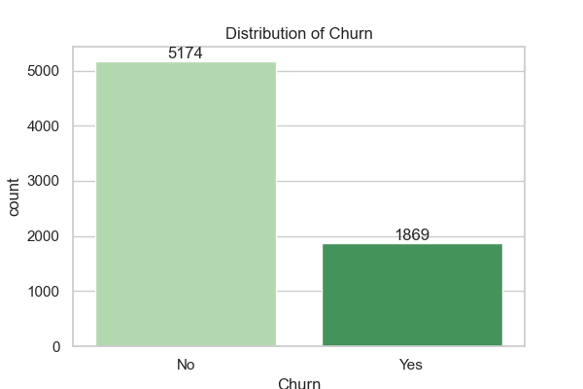
6.1.2 Telecom Partner vs Gender
Graph Used: Bar Chart (countplot)
Values: Evenly distributed
Female Male
airtel 868 861
bsnl 892 863
jio 867 868
vodafone 861 963
Observation:
Every telecom partner has an almost equal number of male and female customers.
Insight:
This confirms the Random Assignment logic was successful. It creates a fair "test environment" where no partner has a demographic advantage.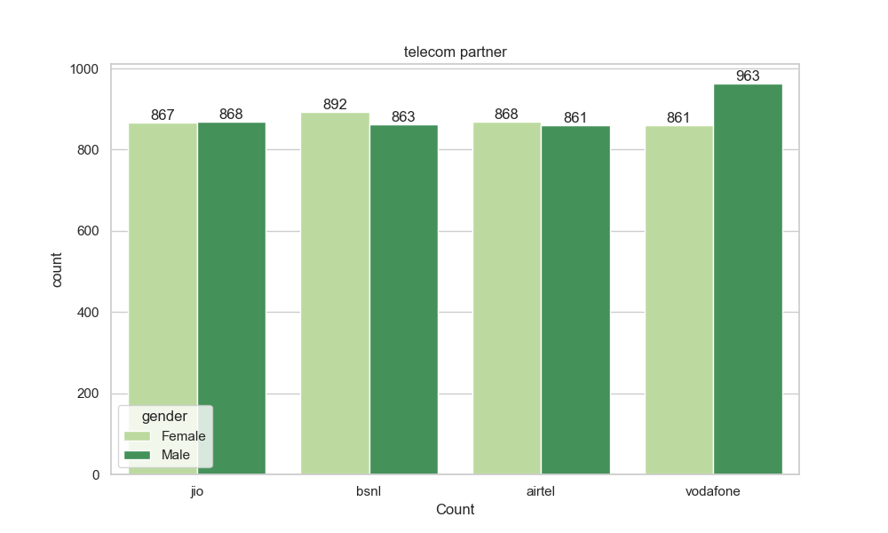

6.1.3 senior citizen in telecom partner
Graph Used: Bar Chart (countplot)
Values: Non-Seniors (~1,450 per partner) | Seniors (~280 per partner).
Senior Citizen airtel bsnl jio vodafone
0 145 1466 1467 1523
1 284 289 268 301
Observation:
The ratio of young to old customers is consistent across all four partners.
Insight:
If one partner shows higher churn later, we know it’s due to their service quality, not because they happen to have more senior citizens.
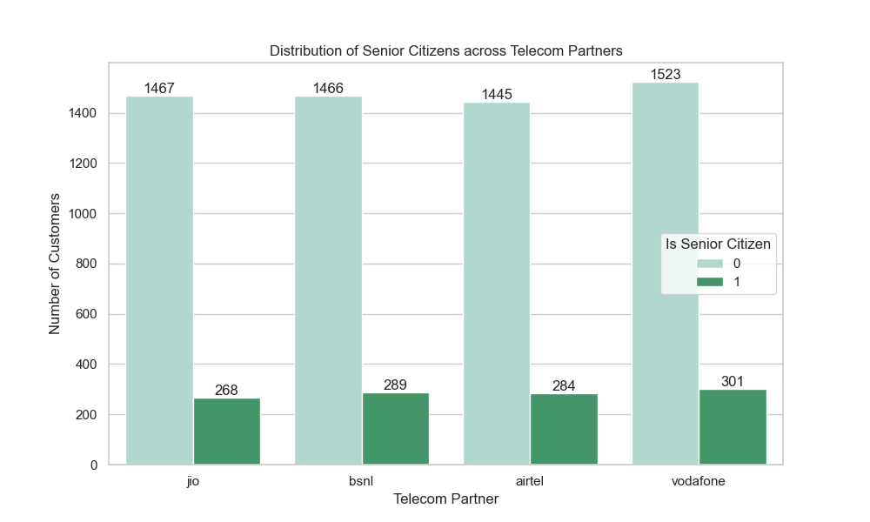
6.1.4 Gender Distribution
Graph Used: Bar Chart (countplot)
Values: Male: 3,555 | Female: 3,488
Observation: The customer base is split almost exactly 50/50.
Insight: Since the population is balanced, we can trust that our churn analysis isn't biased toward one gender.
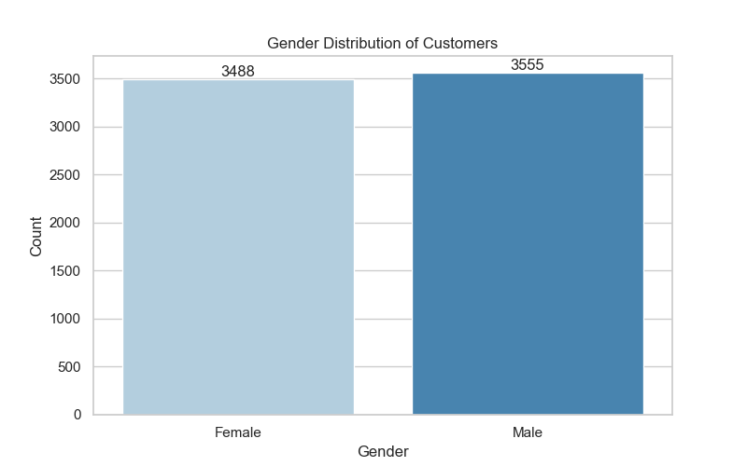
6.1.5 Gender vs Churn
Graph Used: Bar Chart (countplot)
Values: gender Churn Count
Female No 2549
Female Yes 939
Male No 2625
Male Yes 930
Observation:
The number of people leaving is nearly identical for both genders.
Insight:
Gender is not a driver for churn. Retention strategies do not need to be gender-specific; a "one-size-fits-all" demographic approach works here.
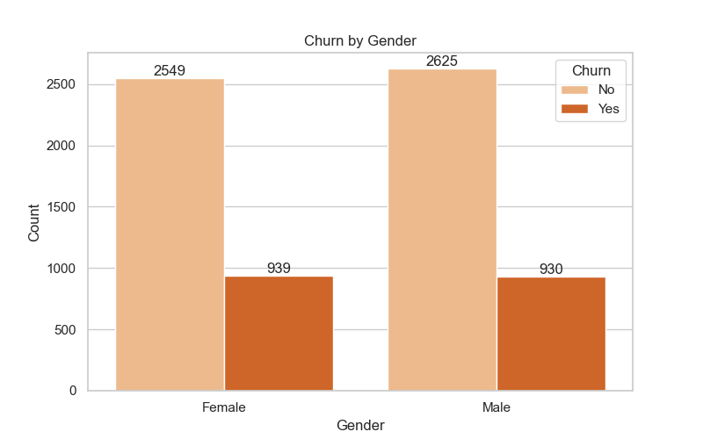
6.1.6 Gender Breakdown (No Internet Service)
Graph Used: Bar Chart (countplot with query)
Values: Female: 747 | Male: 779
Observation:
Even in the "Basic Phone Only" segment, the gender split remains equal.
Insight: This group represents "Legacy Users." Their retention depends on simple factors like call reliability and basic plan costs.
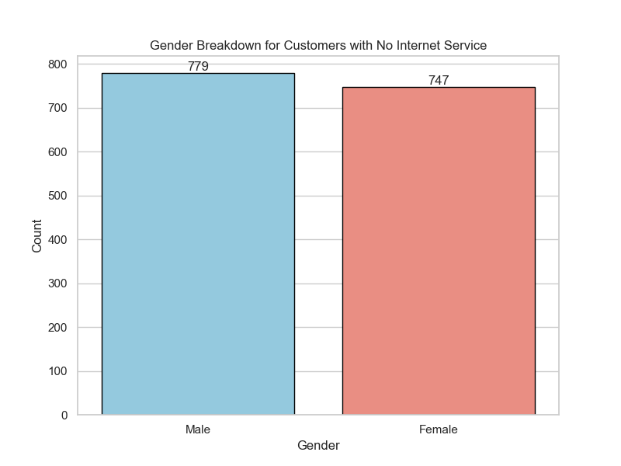
6.1.7 Tenure vs Churn
Graph: Histogram with KDE (histplot)
Values: Average Tenure for Stayed: 37.5 months | Churned: 17.9 months
Observation:
Customers who leave do so much earlier (usually within the first 1.5 years).
Insight: The first year is the "Danger Zone." Improved onboarding and 12-month loyalty rewards are essential.
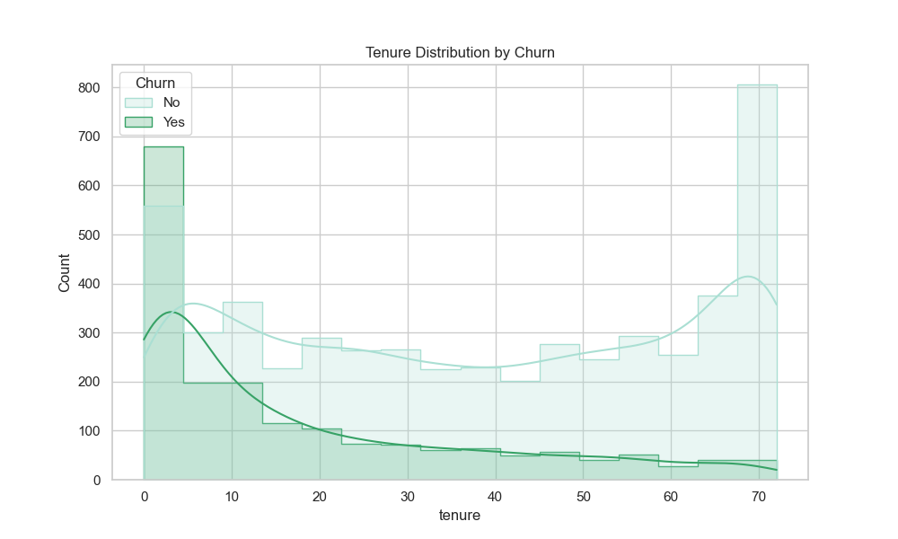
6.1.8 Contract Type Churn
Graph Used: Bar Chart (barplot)
Values: Contract Churn Count
Month-to-month No 2220
Month-to-month Yes 1655
One year No 1307
One year Yes 166
Two year No 1647
Two year Yes 48
Observation:
Customers on "Month-to-month" contracts have a significantly higher churn rate compared to those on one-year or two-year contracts.
Insight:
Contract length is a key predictor of retention. Moving customers from monthly to yearly plans could be a primary strategy for reducing churn.
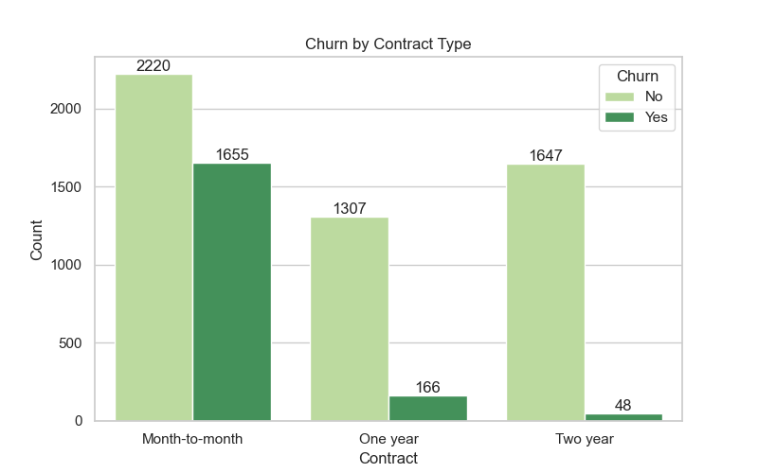
6.1.9 Internet Service Churn
Graph Used: Bar Chart (barplot)
Values:
Internet Service Churn Count
DSL No 1962
DSL Yes 459
Fiber optic No 1799
Fiber optic Yes 1297
No No 1413
No Yes 113
Observation:
"Fiber Optic" users churn at a much higher rate than "DSL" or "No Internet" users.
Insight:
Even though Fiber is a premium service, it may have technical issues or high costs that dissatisfy customers. This service tier needs a quality-of-service audit.
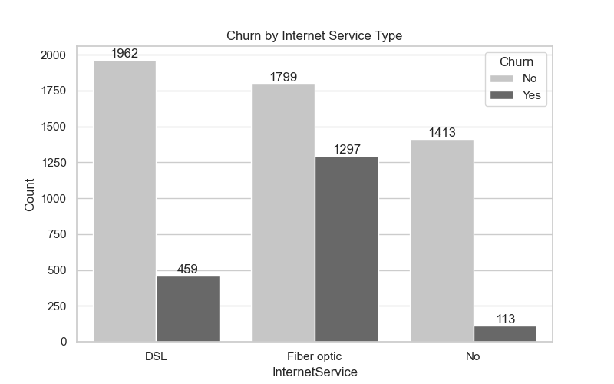
6.1.10 Payment Method Churn
Graph Used: Bar Chart (barplot)
Values:
Payment Method Churn Count
Bank transfer (automatic) No 1286
Bank transfer (automatic) Yes 258
Credit card (automatic) No 1290
Credit card (automatic) Yes 232
Electronic check No 1294
Electronic check Yes 1071
Mailed check No 1304
Mailed check Yes 308
Observation:
Customers using "Electronic Check" are significantly more likely to churn than those using automatic methods like Credit Card or Bank Transfer.
Insight:
Manual payment methods create a monthly where customers reconsider their subscription. Encouraging "Auto-pay" could indirectly improve retention.
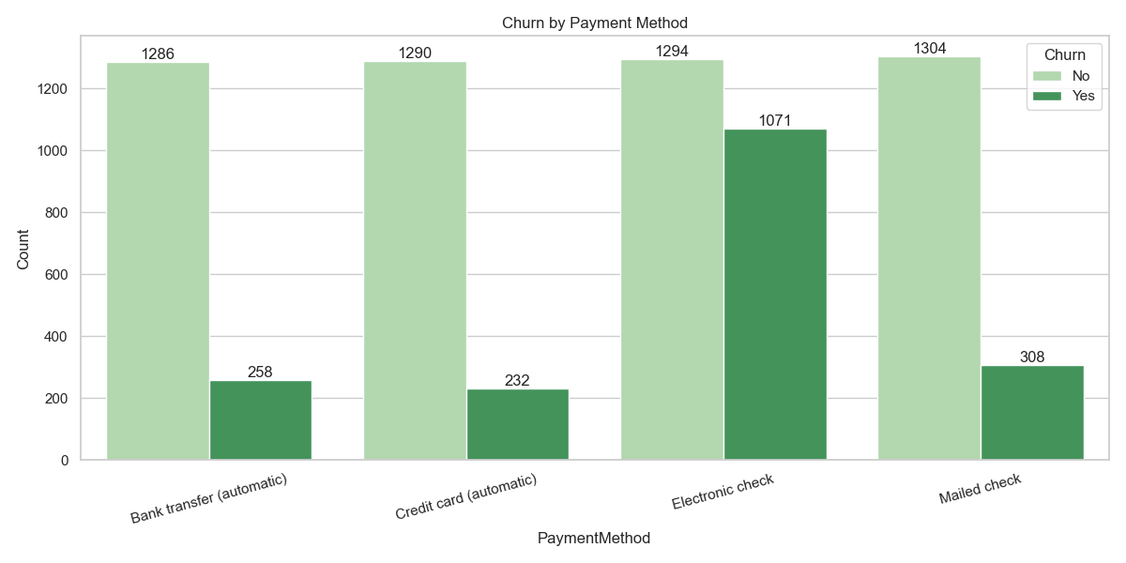
6.1.11 Senior Citizen vs Churn
Graph Used: Bar Chart (countplot)
Values:0 No 4508
Yes 1393
1 No 666
Yes 476
Observation: Senior citizens have a higher percentage of churn compared to younger customers.
Insight: Senior customers might face usability challenges or have different service needs. Targeted assistance or simplified billing for this demographic could improve retention.
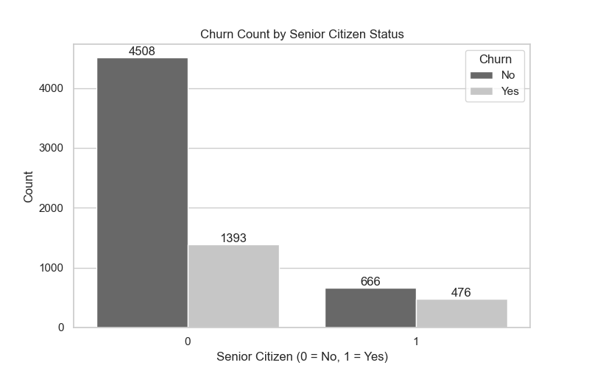
6.1.12 Senior Citizen Distribution by Gender
Graph Used: Bar Chart (countplot)
Values:
Senior Citizen 0 1
Female 2920 568
Male 2981 574
Observation:
Shows the count of Senior Citizens within each gender category.
Insight:
This provides a granular demographic profile, helping us understand the exact size of our "Most Vulnerable" (Older) vs. "General" (Younger) customer segments.
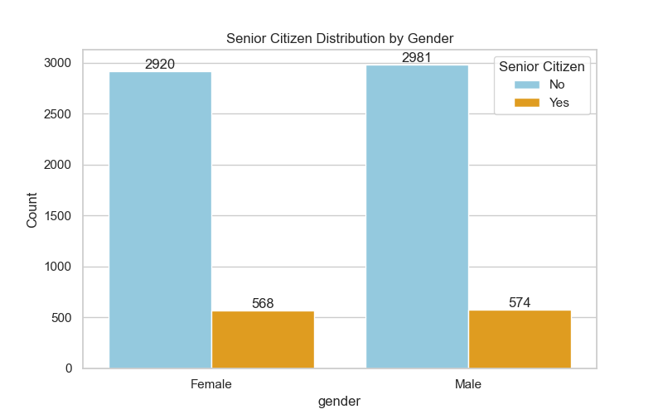

6.2 EDA Insights & Implementation
- Month-to-month plans see massive churn, while Two-year contracts show almost total loyalty
- High monthly bills act as a major red flag for customer exit.
- Electronic checks have the highest churn rate compared to low-risk automatic payment methods.
- Senior citizens are a high-risk group, churning at nearly double the rate of younger customers.
- Churn is almost identical for males and females, proving gender is not a driver for leaving.
- Fiber optic users churn more frequently than DSL users, indicating issues with premium service value.

6.3. Conclusion
Successfully completed visualization for the churn prediction:
- Understanding customer behaviour through data
- Identifying major churn driver
- Visualizations patters clearly using dashboards
- Preparing the data for feature engineering and model building in steps

7. Train- Test Split
- Data Set: The data loaded 7,043 rows with 21 columns.
- Data Partitioning: The dataset was divided into training and testing sets to ensure the model could be evaluated on unseen data.
- Training set: 5,634 rows (representing 80% of the total data) were used to build and train the model.
- Testing set: 1,409 rows (representing 20% of the total data) were reserved to verify final accuracy and performance.
- Missing Value: Only the TotalCharges columns had missing values (10 in training, 1 in testing).
8. Feature Selection & Feature Engineering
- Feature selection: Feature selection is the process of choosing the most relevant and important features from the dataset and removing unnecessary or irrelevant ones to improve model accuracy and efficiency.

- Feature engineering: Feature engineering is the process of creating, transforming, or modifying input variables (features) from raw data to make them more suitable for machine-learning models and improve prediction performance.

8.1 Missing Value
Missing value imputation is the process of replacing missing or null values in a dataset with meaningful estimates so that the data can be used effectively for analysis.
8.1.1. Why Missing Values Must Be Handled
Most machine learning algorithms:
- Do not accept null or NaN values
- Assume numerical stability
- Are sensitive to data distribution
Unprocessed missing values can lead to:
- Training failures
- Incorrect distance calculations
- Skewed statistical measures (mean, variance)
Business Impact
From a business perspective:
- Missing customer data can lead to wrong predictions
- Poor churn or risk prediction can affect revenue decisions
- Inconsistent data reduces trust in analytics systems
Therefore, handling missing values is essential to maintain data integrity and business confidence.
Types of Missing Value
- Mean imputation: Replace missing values with the average
- Median imputation: Replace with middle value (robust to outliers)
- Mode imputation: Replace with most frequent value
- Forward/Backward fill: Use previous or next value
- Random sample imputation: It fills gaps by picking a random existing value from the column
Missing value imputation served as the essential first step in the data cleaning pipeline. The system evaluated multiple strategies to decide, total charges has missing values the system chose mode imputation.
8.1.2. Technique selected
Mode imputation:
- This replaces missing values with the most frequent value of the column.
- Mode has selected because it likely resulted in the highest model accuracy compared to using the other techniques.
- In many telecom datasets, total charges are often missing for new customer with 0 moths of tenure.
- Mode is less sensitive to the outlier found in data set then other.

8.1.3. Why other techniques are rejected
Mean imputation:
- Mean is extremely sensitive to outliers.
- Total charges column contains extreme values (outlier) that were later handled by winsorization.
- Your data had "massive bills" (outliers). If you used the average to fill the 11 missing spots, those huge bills would have dragged the average way up. You would have ended up filling those gaps with a very high number that most normal customers don't actually pay.

Median Imputation?
- While the Median is more robust to outliers than the Mean, it can still shift the central tendency of the data if the distribution is heavily skewed.
- Your financial columns were identified as having "skewness," which eventually required Quantile Transformation to fix.

Forward Fill & Backward Fill
- This method assumes that a customer’s bill is the same as the person listed above or below them in the data.
- Since the customer are independent of each other, copying data from a “stranger” in the next row creates logically incorrect data that confuses the machine learning model.

Random Sample Imputation
- This method fills gaps by picking a random existing value from the column. While it preserves the data's "variance" (spread), it introduces randomness.
- With only 11 missing values out of 7,043, adding randomness is unnecessary and can make the results non-reproducible (the model might give slightly different answers every time you run the code).

By using mode imputation for Total Charges, the system successfully moved to the next phase with 0 missing values remaining, fill gaps in Total Charges.

8.2 Outlier Handling
The system identified that different features required different mathematical treatments to prevent outlier from negatively impacting the models performance.
Outliers commonly arise:
- Data entry errors
- Measurement issues
- Exceptional but valid customer behavior
If outliers are not handled properly, they can severely affect:
- Model accuracy
- Distance-based algorithms
- Statistical assumptions
- Business decision reliability
This module is designed to detect, analyze, visualize, and treat outliers using multiple industry-approved techniques and select the most suitable approach.
8.2.1. Why Outlier Handling Is Required
Impact on Machine Learning Models
Outliers can:
- Skew mean and variance
- Dominate loss functions
- Mislead linear and distance-based models
- Cause unstable model training
Algorithms such as Linear Regression, Logistic Regression, KNN, and SVM are particularly sensitive to outliers.
Business Impact
From a business perspective:
- Extreme values can falsely indicate abnormal customer behavior
- Revenue or usage outliers can distort churn predictions
- Decisions based on noisy data reduce trust in analytics
Therefore, outlier treatment is essential to maintain model stability and business credibility.

8.2.2. Technique selected
1.IQR (Inter Quartile Range) Method:
- Used for senior citizen and monthly charges.
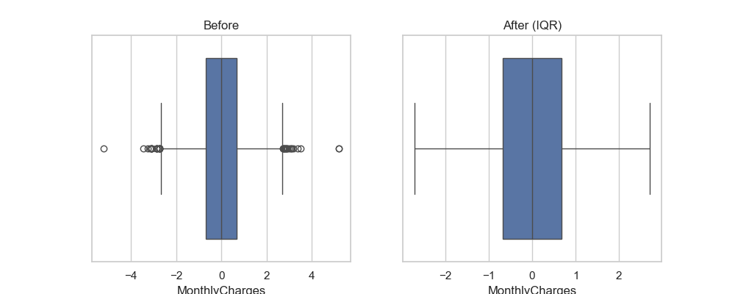

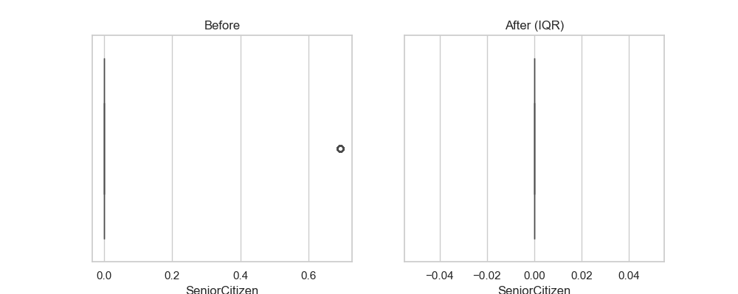
- This method identifies outlier based on the spread of the middle 50% of the data it calculates the difference between the 75th percentile (Q3) and the 25th percentile (Q1)
- Works:
Q1 = Q1 - 1.5 * IQR
Q3 = Q3 – 1.5 * IQR
Is flagged as an outlier and typically removed or placed
- Here it is a robust way to handle monthly charges, ensure the customer with extremely high or low bill compared to the average don’t skew the result.

2. Log Transformation
- Used for tenure.
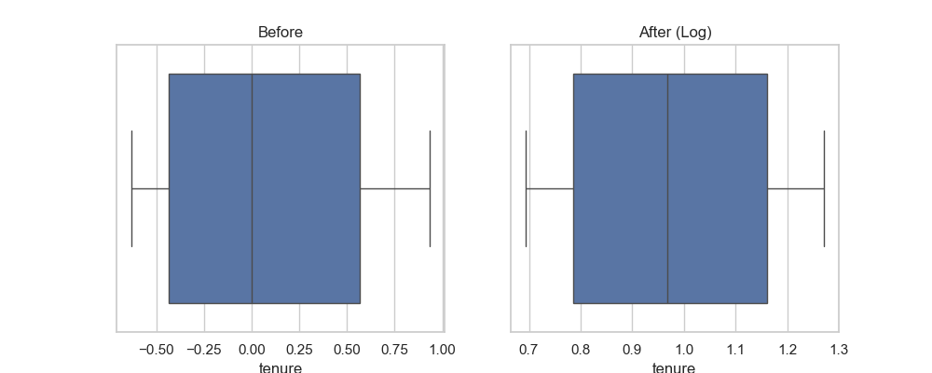
- This technique applies a mathematical logarithm to every value in the column (y = log(x)).
- Work:
Its “squashes” the range of the data. Large data values are pulled closer to the centre, while the relative distance between smaller values are expanded.
- Tenure after has a “right skew” (many new customers with low tenure and a few long
term veterans) log transformation makes this distribution more “normal” (bell shaped) which help algorithms perform better.

3. Winsorization
- Used for Total Charges.
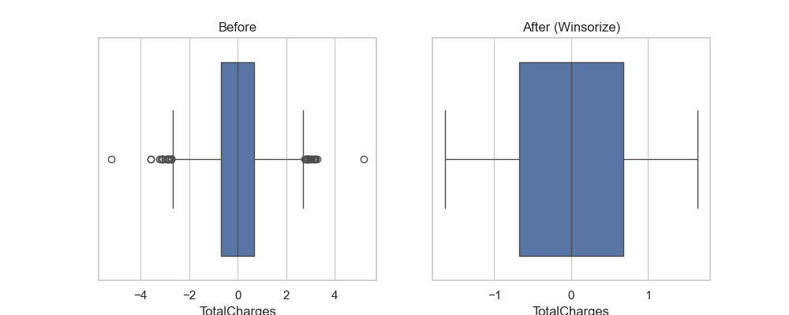
- Instead of deleting outlier winsorization “caps” them at specific threshold (like the 95th percentile).
- Works:
If the 95th percentile for total charges is 8,000, any customer whose total charges are 10,000 will have their value changed to 8,000.
- Total charges represent cumulative revenue, I don’t want to delete high value customer (outliers), but also don’t want their massive totals to over the model.

8.2.3. Why other techniques are rejected
1. Z-score Method
- It uses the Mean and Standard Deviation to identify values that are more than 3 standard deviations away from the average.
- It was not chosen as the “Best Method” for any of your columns in this run.
2. Clipping
- Clipping method only affects the top and bottom 1%.
- For columns like TotalCharges, the outlier was likely more frequent, so Winsorization(5%) we needed to clean the data effectively.

3. Robust Scaling
- Robust scaling handles outlier during scaling, system preferred to fix the data first (using IQR/Winsor) so that the later StandardScaler could work with perfectly cleaned numbers.
4. No Outlier
- Model is sensitive to extreme values. Leaving outliers “as-is” would have allowed massive bills in TotalCharges to distort the model’s weights, leading to low accuracy.

Column | Best Method | Rows
Senior Citizen | iqr | 5634
tenure | log | 5634
Monthly Charges | iqr | 5634
Total Charges | Winsor | 5634

By applying these specific treatments, the system maintained a consistent dataset of 5,634 rows for training without losing critical information to simple data deletion.

8.3 Variable Transformation
Variable transformation is the process of applying mathematical function to data to change its distribution or scale. This step targeted numerical column to reduce “skewness” (when data is bunched upon one side), making the data suitable.
numerical features are often:
- Highly skewed
- Non-normally distributed
- Affected by extreme values
Many machine learning algorithms assume or perform better when features follow a near-normal distribution. This module is designed to systematically apply, evaluate, and select the best numerical transformation technique using an objective, data-driven approach.
8.3.1. Why Variable Transformation Is Required
Impact on Machine Learning Models
Untransformed numerical variables can:
- Bias linear and distance-based models
- Slow model convergence
- Reduce interpretability
- Increase model error
Models such as Logistic Regression, Linear Regression, KNN, SVM, and Neural Networks are particularly sensitive to skewed data.
Business Impact
From a business perspective:
- Skewed financial or usage data can mislead churn predictions
- Extreme values can dominate customer segmentation
- Poor transformations reduce trust in analytical outputs
Variable transformation ensures balanced learning across all customer profiles.
8.3.2. Technique selected
1. Log Transformation:
- Applied to SeniorCitizen
- Why: This feature has a high skewness of 1.8467.
- Reasoning: Log transformation is highly effective for right-skewed data. It "compresses" the long tail of the distribution, making the feature more normal and preventing large values from disproportionately influencing the model.

2. Robust Scaling:
- Applied to tenure
- Why: It has a relatively low skewness of 0.2399.
- Reasoning: Since the distribution is nearly symmetrical but may contain outliers common in "tenure" data (e.g., brand-new vs. very long-term customers), RobustScaler is used. It scales data based on the Interquartile Range (IQR), ensuring outliers don't shrink the majority of the data into a tiny range.

3. Quantile Transformation:
- Applied to MonthlyCharges & TotalCharges
- Why: These have extremely low skewness (0.0195 and 0.0039 respectively).
- Reasoning: Even though they aren't skewed, their distributions might be multi-modal or non-Gaussian. Quantile transformation maps the data to a Normal Distribution. This is "best" for linear models or algorithms that assume normally distributed inputs.

8.3.3. Why other techniques are rejected
1. Standard Scaling (Rejected for Outliers)
- The Math: It calculates the Mean and Standard Deviation.
- The Failure: Because it uses the average, one extremely high "TotalCharge" or "MonthlyCharge" pulls the mean toward it.
- The Result: Most of your normal customer data gets squashed into a tiny, indistinguishable range, making it hard for the model to learn patterns.

2. Minmax Scaling (Rejected for Shape)
- The Math: It simply squeezes all values into a fixed range, usually between 0 and 1.
- The Failure: It does nothing to fix skewness (lopsided data).
- The Result: If your data starts out heavily lopsided—like your SeniorCitizen column with a skew of 1.8467—it stays just as lopsided after scaling, which performs poorly in many algorithms.

3. Box-Cox (Rejected for Data Constraints)
- The Math: This is a power transform that only accepts strictly positive numbers.
- The Failure: Your dataset contains zeros, such as in the SeniorCitizen column (where 0 means "not a senior").
- The Result: Trying to run Box-Cox on this data would cause a mathematical error and crash your script.

4. Yeo-Johnson (Rejected for Complexity)
- The Math: It is a more advanced, computationally "expensive" version of Box-Cox that handles zeros and negative numbers.
- The Failure: It was unnecessary for your specific data.
- The Result: Your logs show that simpler methods, like Quantile Transformation, already achieved a near-perfect skewness of 0.0039. Using Yeo-Johnson would be like using a sledgehammer to crack a nut—it wastes processing power for no extra gain.
Feature | Skewness | Applied Technique
SeniorCitizen | 1.8467 | Log Transformation
tenure | 0.2399 | Robust Scaling
MonthlyCharges | 0.0195 | Quantile Transformation
TotalCharges | 0.0039 | Quantile Transformation

By forcing this financial figure into a “bell curve” shape, the model can more easily identify pattern and relationship.

8.4 Categorical to Numerical
In the process where the system tested different ways to convert text-based information (categorical data) into number that a model can understand.
This module implements a pipeline-safe, production-ready encoding strategy that ensures:
- No data leakage
- Safe handling of unseen categories
- Scalability for real-world deployment
8.4.1 Why Feature Encoding Is Required
Machine Learning Perspective
Machine learning models:
- Cannot directly interpret text or categorical labels
- Require numerical input to compute distances, weights, and probabilities
If categorical features are not encoded:
- Model training fails
- Predictions become unreliable
Business Perspective
Incorrect encoding can:
- Introduce bias
- Create false ordinal relationships
- Break deployed systems when new categories appear
Therefore, encoding must preserve business meaning, statistical integrity, and production safety.
8.4.2. Technique selected
Label Encoding
- Label Encoding was selected as the best.
- It keeps all information in a single column rather than creating multiple new ones, which kept your total feature count at a manageable 20.
- By not adding extra columns, it ensures the model doesn’t get “confused” by too many variables, which helped to reach good accuracy.
- Its mathematically simple and fast for the system to process.

8.4.3. Why other techniques are rejected
1. One-Hot Encoding
- It creates a new column for every single column category. For example, my log show that telecom_partner was expanded from 1 column to 3 columns.
- If applied to all 16 variables, your dataset would have exploded in size, making it redundant and harder for the RFE (Recursive Feature Elimination) to find the truly important feature later.

2. Binary Encoding
- It represents categories as binary digits across multiple columns.
- Even for simple features like gender, it created two columns (gender_0 and gender_1), which is redundant when one column (0 or 1) does the same job more efficiently.

3. Frequency Encoding
- It replaces names with the “count” of how often they appear (e.g., replacing a partner name with 1391).
- This risk because if two different partners (like Jio and Airtel) have the same number of customers, the model will think they are exactly same, losing critical business information.

4. Ordinal Encoding
- It assumes there is a “rank” or “order” (like Small < Medium < large).
- Using this for gender or telecom_partner makes no sense because one partner isn’t “mathematically higher” than another. It was only used for features with a natural order, like Contract.
By selecting label Encoding, the system ensure that final training shape remained at (5635, 20). If it had chosen One-Hot Encoding for all columns, it might have ended up with 40 or 50 features. Which can lead to “overfitting” -where the model memorizes noise instead of learning patterns.

8.5 Feature selection
Feature selection is the process of reducing the number of input variable to only the most important ones. The system started with 20 features and used different techniques to find the most “predictive” subset to improve model speed and prevent overfitting.
This module implements a robust, multi-method feature selection framework focused on numerical features, following industry best practices to improve:
- Model accuracy
- Generalization
- Training efficiency
- Interpretability
8.5.1 Why Feature Selection Is Required
1.Machine Learning Perspective
Using all available features can:
- Increase overfitting
- Add noise to the model
- Increase computational cost
- Reduce model stability
Many algorithms perform better when trained on a compact and informative feature set.
2. Business Perspective
From a business standpoint:
- Too many features make models harder to explain
- Irrelevant features reduce stakeholder trust
- Lean models are easier to deploy and maintain
Feature selection helps create efficient and explainable models suitable for production environments.
8.5.2. Technique selected
RFE (Recursive Feature Elimination)
- It repeatedly builds a model and removes the least important feature one by one until it reaches the optimal set.
- This system identified RFE as best because it narrowed down data just 2 key feature while likely maintain high accuracy.
- It reduce complexity from 20 variable down to 2 model with few features are run in production level.

8.5.3 Why other techniques are rejected
1. Low Variance Filter (drop_low_variance)
- It identifies and removes features where the values are almost the same for every customer. If a column has very little "spread" (low variance), it provides no useful information for the model.
- This technique narrowed the data down from 20 to 4 features.

2. Correlation Filter (drop_redundant_features)
- It looks for pairs of features that are highly similar to each other. For example, if "Tenure" and "TotalCharges" were 95% identical, one would be dropped to avoid mathematical "crowding".
- This technique kept all 20 features, suggesting no two columns were excessively redundant at the set threshold.

3. SelectKBest (select_top_features)
- It uses statistical tests (ANOVA F-test) to rank features based on their direct relationship with the target ("Churn") and picks the top "K" performers.
- This technique kept 4 features.

4. Feature Importance (select_by_importance)
- It uses a Random Forest model to rank features by how much they contribute to correctly splitting the data into "Churners" and "Non-Churners".
- It typically keeps columns that score above the average importance level.
Technique | Efficiency | Result
Variance | Moderate | 4 features
Correlation | Low | 20 features
KBest | Moderate | 4 features
RFE (Winner) | High | 2 features

8.6 Data Balancing
Data Balancing was a critical phase used to address the unequal distribution of customers who stayed versus those who churned. Initially, training data was heavily imbalanced, with 4,138 "No Churn" cases (Class 0) and only 1,496 "Churn" cases (Class 1).
8.6.1 Technique selected
SMOTE-ENN
- This is a two-step hybrid method. First, it uses SMOTE to create synthetic churners, and then it uses ENN (Edited Nearest Neighbors) to clean the data by removing noisy points that blur the lines between the two classes.
- Although it required strictly numeric input (which system provided after categorical encoding), it was the selected strategy because it provides a "cleaner" boundary for the model to learn.
- It achieved the highest F1 score of 0.8947, proving that a combination of adding data and cleaning up noise was the most effective strategy for telecom dataset.

8.6.2. Why other techniques are rejected
1.Random Under Sampling (RUS)
- This method randomly removes example from the majority class [No Churn] until it matches the number of the minority class [‘Churn’]
- It is very fast, but it is often wasteful because because it throws away potentially valuable data from 4,138 stay records.
- It yielded an F1 score of 0.7267, which was decent but not the best

2.Random over sampling (ROS)
- It works instead of removing data this method duplicates existing records from the minority class (“Churn”) until the class are equal.
- We can’t lose any data but duplicating roes can lead ton overfitting where the model simplify “memorizes” specific customers rather than learning general trends.
- It achieved an F1 score of 0.7296

3. SMOTE (Synthetic Minority Over-Sampling Technique)
- Smote doesn’t just duplicate data, it creates new, synthetic examples of churns by looking at existing one and creating similar mathematical profiles.
- It provides more variety for the model to learn from the simple duplication.
- It resulted in an F1 score of 0.7251.

4. ADASYN (Adaptive Synthetic Sample)
- It works similar to SMOTE, but it focuses specifically on area where minority class is “harder to learn”.
- While smart, it can sometimes accidently create synthetic data out of “noise” or error in the data.
- Result: it had the lowest F1 score of 0.7034.

5. SMOTE-ToMek (Hybrid)
- This is the combination method that uses SMOTE to add data and then uses “ToMek Links” to remove pairs of data points that are too close to each other and causing confusion.
- It performs well with an F1 score of 0.7489.
technique | F1 Score
Random Under Sampling | 0.7267
Random Over Sampling | 0.7296
SMOTE | 0.7251
ADASYN | 0.7034
SMOTE -ToMek | 0.7489
SMOTE - ENN | 0.8947

8.7 Feature Scaling
Feature scaling is a data preprocessing technique used to normalize the range of independent variable or feature of data.
8.7.1 Technique selected
Standard Scaler
- The best technique, it shifts data so the mean is 0 and the standard deviation is 1. It assumes a bell-shaped distribution.
- It achieved the highest F1 score of 0.5265.

8.7.2. Why other techniques are rejected
1.Min Max Scaler
- Scales all data due to fixed range usually between 0 and 1. It is sensitive outliers.
- It is a lower F1 Score of 0.5242. it is highly sensitive to outlier, if one customer has an extremely high bill, it squashes all other customers data into a tiny indistinguishable range near zero.
2. Robust Scaler
- Uses the median and interquartile range (IQR), making it resistance to outlier that might still exist.
- It scored 0.5244. since already applied winsorization to cap your outlier earlier, the extra protection of robust scaler wasn’t necessary.

3. Max Abs Scaler
- Scales each feature by its maximum absolute value so that the max value is 1.0. it doesn’t shift/centre the data.
- It scored 0.5234. This method doesn’t “centre” the data.

4. Normalize
- Unlike the other this scaler rows instead of columns to have a “unit norm”.
- This was the worst performer with an F1 score of 0.3513. Normalization or clustering not for tabular customer data where the relationship between different customers charges is critical.

9. Model Selection
The Model Selection phase was the ultimate competition in project, where nine different machine learning algorithms were evaluated to find the most accurate predictor for customer churn. The system utilized a "common" evaluation framework to ensure each model was tested under identical conditions using the scaled and balanced data.
Objective of Model Training
The objectives of this module are:
- Train multiple classification algorithms
- Evaluate models using consistent metrics
- Compare model performance visually and quantitatively
- Select the best model based on objective criteria
- Save trained artifacts for deployment
9.1. Data Preparation Before Training
Before training any model:
- Only numerical features are used
- Infinite values are removed
- Missing values are safely handled
This ensures:
- Model compatibility
- Stable numerical computation
- Reduced runtime errors
This preprocessing step mirrors production inference conditions.

9.2 Model Selected
Logistic Regression
- Logistic Regression was selected as the Best Model because It achieved a Test Accuracy of 80.62%, outperforming every other model in the competition.
- It earned the highest ROC-AUC Score of 0.8393, proving it is the most reliable model for separating potential churners from loyal customers.
- It is a mathematically "lean" model that works extremely well with the 2 key features your RFE process selected.
9.3 Why other techniques are rejected
1. Decision Tree
- Flaw: Overfitting.
- A Decision Tree acts like a flowchart that keeps splitting data until it reaches a conclusion. Because it tries to be too perfect, it "memorizes" the noise and specific quirks of your training data.
- Result: When you showed it the unseen test data, it failed to generalize, leading to the lowest accuracy (72.39% Accuracy) in your entire competition.

2. Random Forest & AdaBoost
- Flaw: High Complexity for Low Return.
- These are "Ensemble" models that combine many small trees to make a decision. While powerful, they require more computational power and time to tune.
- Result: Despite being more complex, they yielded significantly lower accuracy (75.44% - 75.73% Accuracy) than your simpler Logistic Regression, proving that "complex" doesn't always mean "better" for this dataset.

3. SVM
- Flaw: Poor Probability Ranking (Low ROC-AUC).
- While SVM was close in accuracy (79.91% Accuracy), its ROC-AUC (0.6730) was very poor compared to the winner's 0.8393. SVM focuses on drawing a hard "boundary" line between customers who stay and those who leave.
- Result: It struggled to provide a reliable "probability" of churn. In a business, we need to know how likely a customer is to leave (e.g., 90% vs 51%), and SVM is not naturally good at that ranking.

4. XGBoost & Gradient Boosting
- Flaw: Over-Engineering for Small Feature Sets.
- These are high-performance models designed for massive datasets with hundreds of variables. However, RFE process reduced your data to just 2 critical features and its accuracy is (76.37% - 78.92% Accuracy).
- Result: Using XGBoost and Gradient Boosting on only 2 features is like using a rocket engine to power a bicycle—it’s unnecessary and often less stable than simple math like Logistic Regression for a small number of inputs.

5. KNN & Naive Bayes
- Flaw: Computational Weight and Unrealistic Assumptions.
- KNN (K-Nearest Neighbors): This model has to calculate the distance to every single neighbor for every new prediction, making it very slow as your customer list grows.
- Naive Bayes: It assumes that every feature (like tenure and MonthlyCharges) is completely independent of the others.
- Result: In reality, a customer's total bill is highly related to their tenure, so Naive Bayes' "independent" assumption was mathematically incorrect for project and its accuracy is (77.57% - 78.78% Accuracy).

9.4 Optimization via Grid Search
The system did not use default settings. It performed an exhaustive GridSearchCV to find the "Best Parameters" for the Logistic Regression model:
- Best Parameters: {'C': 100, 'penalty': 'l2', 'solver': 'saga'}.
- C: 100: This indicates a high inverse regularization strength, allowing the model to fit the training data more closely.
- Penalty: l2: Used Ridge regularization to prevent the model's weights from becoming too large.
- Solver: saga: A fast optimization algorithm that works well with large datasets and L2 penalties.
9.5 Visualizing Success (ROC Curve)
The system generated an ROC Curve for all models to compare their ability to distinguish between "Churners" and "Non-Churners".
- ROC-AUC (0.8393): This score represents the area under the curve; a value of ~0.84 is considered very strong, proving the model is highly reliable at ranking a random "Churner" higher than a random "Stayer".

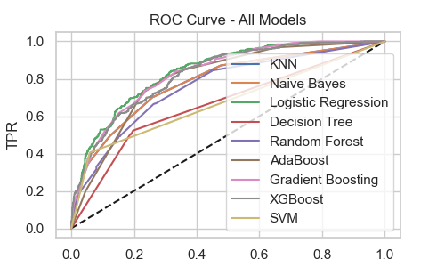
9.6 Model Performance Leaderboard
The following table summarizes the test results for all evaluated algorithms, ranked by their accuracy:
Rank | Model | Test Accuracy | ROC-AUC Score
1 | Logistic Regression | 80.62% | 0.8393
2 | SVM (Support Vector Machine) | 79.91% | 0.6730
3 | XGBoost Classifier | 78.92% | 0.6730
4 | Naive Bayes (Gaussian) | 78.92% | 0.8249
5 | KNN (K-Nearest Neighbors) | 77.57% | 0.7823
6 | Gradient Boosting | 76.37% | 0.8305
7 | Random Forest | 75.73% | 0.7432
8 | AdaBoost | 75.44% | 0.8009
9 | Decision Tree | 72.39% | 0.6544

10. Pickling
Pickling is the process of converting a Python object into a byte stream. This byte stream is saved as a .pkl file, which can be stored on a hard drive and "unpickled" later to restore the object to its original state.
The Files Saved in Project
According to feature_scaling
scaler_path.pkl
- The trained StandardScaler object.
- Why it's needed: When a new customer enters their data in app, their raw numbers must be scaled using the exact same Mean and Standard Deviation used during training. Without this file, the model wouldn't understand the new data's scale.
train_columns.pkl
- A list containing the names and order of the final features used for training.
- Why it's needed: The model expects input features in a very specific order. If the web app sends "MonthlyCharges" before "tenure" but the model expects the opposite, the prediction will be wrong. This file acts as a "map" to keep the data organized.
According to model selection
- model.pkl: The trained and optimized Logistic Regression model was saved for future predictions.
- scaler.pkl: The specific scaler used during training was saved to ensure new input data is normalized identically.

11. Frontend
11.1. The User Interface (index.html)
The frontend provides a clean, grid-based form for data entry:
- Data Collection: It gathers 12 specific customer attributes, including demographics (Gender, Partner), services (Internet Service, Tech Support), and financial metrics (Monthly Charges, Total Charges).
- Hidden Parameters: To keep the user experience simple, the form automatically sends 8 default values (like PhoneService and OnlineSecurity) as hidden inputs.
- Dynamic Feedback: The page uses Flask's template engine ({% if prediction_text %}) to display the result directly on the same page after the user clicks the button.
11.2. The Prediction Engine (app.py)
This script acts as the "brain" connecting user interface to trained models:
- Loading Intelligence: It unpickles the three essential components created during training: the best model, the best scaler, and the final feature list.
- Feature Alignment: It converts the raw form data into a DataFrame and uses reindex to ensure the columns exactly match the order and names expected by the model.
- Scale and Transform: It applies the saved StandardScaler to the new data, ensuring the inputs are on the same scale as the training data.
11.3. Probability and Decision Threshold
Instead of a simple "Yes/No," system uses Soft Classification:
- Predict Proba: The model.predict_proba function is used to get the exact percentage of churn risk.
- Custom Threshold (0.4): implemented a more sensitive threshold. If the risk is 40% or higher, the system flags the customer as "Will Churn".
- Why 0.4?: In customer retention, it is often better to catch a "high risk" customer early (even at 40% risk) so the company can offer them a discount or support before they actually leave.
Step | Action | Logic Location
Input | User enters data for tenure, charges, etc. | index.html
Preprocessing | Data is encoded and aligned with train_columns.pkl. | app.py
Scaling | scaler.pkl normalizes the numeric values. | app.py
Prediction | model.pkl calculates the churn probability. | app.py
Output | Result is displayed with a risk percentage. | index.html

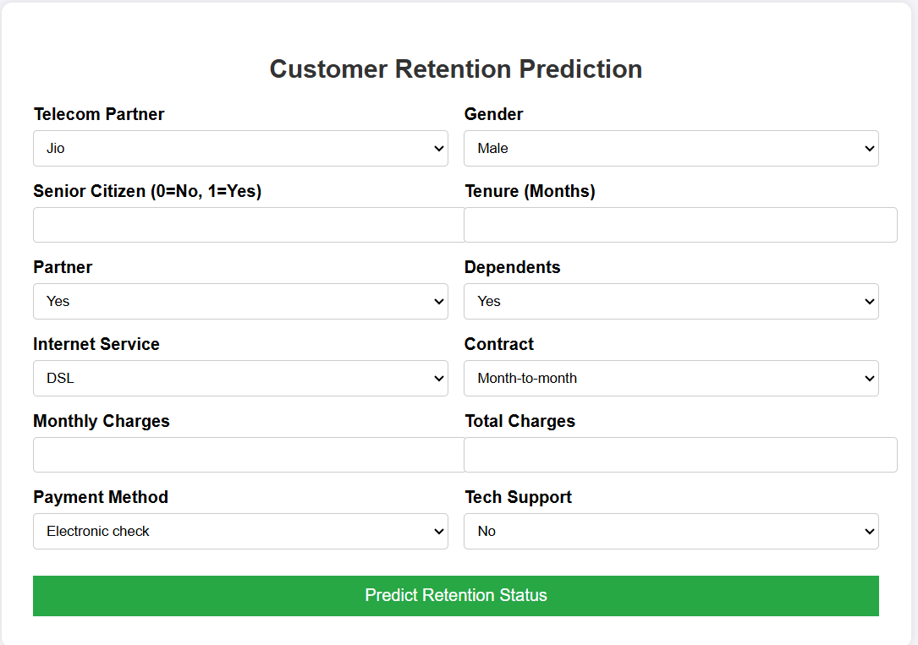
12. Deployment Configuration
File Name: Procfile
the Procfile is the "instruction manual" for the Render platform. It ensures that your Customer Retention Prediction system doesn't just sit in a GitHub repository, but actually runs as a live service that users can access via your web link.
12.1. The Core Infrastructure
- The Procfile: This file is the "entry point" that tells Render exactly how to start your web service. It specifies the process type (web) and the command to launch your application server.
- The Application Server (Gunicorn): While you used Flask's built-in server for testing, the Procfile enables a production-grade server like Gunicorn to handle live web traffic reliably.
- Artifact Loading: At startup, the Procfile-initiated process loads your trained intelligence—the model.pkl and scaler.pkl—so the system is ready to predict without retraining.

12.2. Why This Setup Is Industry-Standard
- Automation & CI/CD: By using a Procfile and connecting GitHub to Render, you’ve enabled Continuous Deployment. Every code change you push is automatically built and redeployed without manual intervention.
- Consistency: The Procfile ensures that the application starts with the same behavior in production as it did in your local environment, reducing "it works on my machine" errors.
- Scalability: This configuration allows the platform to scale your prediction service, making it ready to handle a high volume of inference requests from multiple users.

12.3. The Live Inference Workflow
When someone visits your Live Web App:
- Input: The user enters customer data (like tenure or MonthlyCharges) into your HTML form.
- Processing: Your Flask backend (app.py) receives the data, cleans it using train_columns.pkl, and normalizes it using scaler.pkl.
- Prediction: The system calculates the churn probability. If the risk is 40% or higher (your 0.4 threshold), it warns the user that the customer is likely to leave.

13. Final Project Verdict
This system is a robust, data-driven tool that effectively bridges the gap between complex machine learning and practical business operations. It provides a scalable foundation for any telecom provider looking to reduce churn and increase customer lifetime value through artificial intelligence.
Live Project Link: https://ai-powered-customer-retention-prediction-3tyr.onrender.com .

14. Conclusion
The conclusion of this project demonstrates a successful end-to-end implementation of a Customer Retention Prediction System, moving from raw data processing to a live, cloud-deployed web application. By applying rigorous data science methodologies, the system provides actionable insights for businesses to identify and retain at-risk customers.

